Chapter 8 : The First Line Period,
30 June – 27 July, 1966

Since Oriskany’s ’65 cruise, there have been a lot of changes in the way the air war is being fought. Now there are two separate locations in the Tonkin Gulf for locating aircraft carriers. Dixie Station is off the coast of South Vietnam, from where aircraft carriers launch airstrikes against Viet Cong guerillas under the direction of airborne forward air controllers. Yankee Station is the reference point location in the gulf for launching air strikes against North Vietnam. In that way the maneuvering aircraft carriers and their escorting destroyers don’t get in each other’s way. So, one carrier will constrain its movement to an area north of Yankee Station, another to an area east of Yankee Station, and the third to an area south of Yankee Station. That way the ships don’t run into Asia, or each other, and their planes don’t run into each other.
Carriers head into the wind when launching and recovering aircraft. The prevailing winds in the Tonkin Gulf blow from the west. Thus a carrier, more often than not, heads west toward the coast of North Vietnam. Between the end of the launch and beginning the recovery of the previous strike, the ship has to hustle back east while staying within bounds of the assigned sector in reference to Yankee Station. All these factors make driving the ship a challenge for the officers on Oriskany’s bridge.
Typically, there are three CVA’s (attack carriers) assigned to Yankee Station at all times. One flies a twelve- hour period of daylight strike operations from dawn to dusk, another flies from noon to midnight, and a third flies from midnight to noon. In that way there are always two air wings over North Vietnam during the daylight hours, and one during the night. There is usually a fourth carrier in the gulf that covers the gaps when one of the others transit back and forth to Rest and Recreation (R&R) port calls (Subic Bay, Hong Kong, Sasebo, Singapore). When there are no gaps to be covered, the fourth carrier is available to move south intermittently to Dixie Station to provide air strike support for our ground troops in South Vietnam. An aviator Rear Admiral riding one of the big deck carriers is Commander of Task Force 77 (all the aircraft carrier groups in the Seventh Fleet). His radio call sign is JEHOVAH. His people keep track of who is on Yankee Station bombing north, and when, and who is bombing south from Dixie Station. Each carrier and its destroyer escort(s) are a Carrier Task Group (CTG). For example, Oriskany and its plane-guard destroyer might be CTG 77.3. Our radio callsign is CHILDPLAY.

When we arrive in the Gulf of Tonkin, JEHOVAH assigns us to Dixie Station for eight days. The Viet Cong in SVN have no air defense capability except for their personal Kalashnikov AK-47’s which can throw some small bullets up a thousand feet or so. When our planes come to bomb, the VC are generally in “I-hope-they-don’t-see-me!” mode snuggling with the jungle mud. For the aviators it’s a permissive environment. It’s a warm-up for more dangerous Yankee Station operations next week.

We go to full 12-hour cyclic operations. After launch, our bomb-droppers (Skyhawks and Spads) check in with an airborne Forward Air Controller (FAC) over South Vietnam who is in radio contact with our troops on the ground or is searching for activity in areas known to be under VC control. The FAC “parks” our bomb-droppers in orbits off the coast until he has a target for them. Then he calls them in, two at a time, marks the target with a flare he fires at the ground, and has our planes bomb in reference to the flare. The FACs tell us that they prefer the Navy bomb-droppers to the Air Force bomb-droppers, because the Navy bombs more accurately. The Air Force no longer has any aircraft designed for close air support. Their F-4 Phantoms and F-105 Thunderchiefs are larger and less maneuverable than the nimble Skyhawks. Most of all - the FAC’s love the Navy Spads (A-1 Skyraiders). They fly low and slow, and carry a smorgasbord of bullets, bombs, and rockets.
Frequently the FACs do not have any targets available. They thank the bomb-droppers and send them home. Because it’s dangerous to recover an aircraft loaded with ordnance on an aircraft carrier, the pilots dump their bombs in the gulf. They set them on “safe”, so they won’t explode but, even so, they have to be careful. There are plenty of fishing boats, merchant ships, and even Navy warships below them. Some of them are US Navy and US Coast Guard ships tracking and inspecting vessels moving south from North Vietnamese waters to see if they are carrying stuff for the Viet Cong.

Scotty, Mike and I (the AI’s from the bombing squadrons) do not have to debrief the pilots to draft OPREP reports from Yankee Station. The FACs will be debriefed at their bases in South Vietnam. Nevertheless, we do “interview” the pilots after their missions. In some cases, their bombs trigger panic by the VC, and they can see them fleeing into open areas on the ground. I can see that the rookie pilots realize that they are now killing people, not scoring points on a bombing range, or knocking down a building, or destroying enemy equipment. Some of our bomb-droppers express satisfaction about killing some VC and helping out our buddies on the ground. Others express no opinion. Is it a dawning realization that this is now real war? . . . and it’s not keeping the peace by being ready for war? I solicit no opinions, just listening as they talk among themselves.

On 7 July we depart Dixie Station and head north to Yankee Station from where we will be bombing North Vietnam.

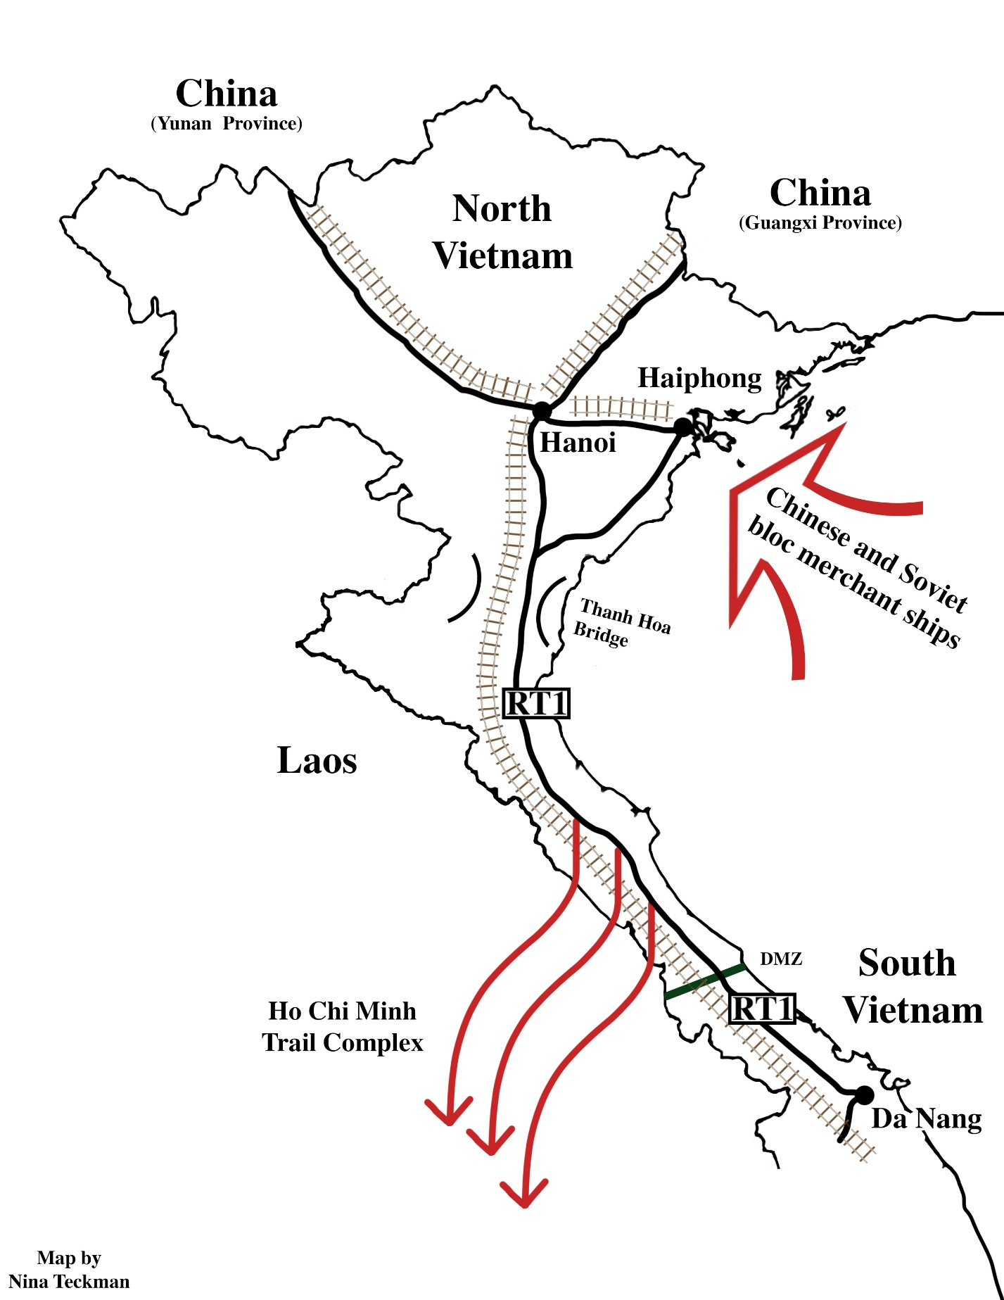

The seaport of Haiphong is a critical factor in North Vietnam’s ability to support the VC insurgency in South Vietnam, and to defend against our air attacks. Vietnam itself produces no weapons. All of them are manufactured in Communist bloc nations and delivered to North Vietnam by sea (via Haiphong), or by land via the NW highway/rail line from Yunnan province (China) and the NE highway/rail link to Guangxi province (China). Previously our Joint Chiefs of Staff recommended the mining of Haiphong and a concentrated air campaign to close down the NW and NE logistic lines (called Lines of Communication, or LOCs in the arcane jargon of military strategy). The strategy was deemed needlessly provocative by President Johnson, The Johnson administration policy will be one of carefully graduated response to continued NVN support to the Viet Cong; hence the complicated rules of engagement referenced by CAG Stockdale. It occurs to me that we are choosing to win the hard way, that we will take a lot more casualties in a war of attrition over NVN while the surface to air missiles (SAMs) and the anti-aircraft guns and ammunition, and new replacement trucks continue an unimpeded flow into Haiphong. Haiphong is so mineable! It’s actually a river port about eight miles from the ocean. One string of naval mines would close it down, or if a brave/foolish merchant ship captain ventured a transit to the wharfs, a sunken ship would block the channel.
North Vietnam is generally a mountainous country in the north except for the Red River delta. The Red River flows out of the mountains of Yunnan province of China to the southeast into northwestern North Vietnam. It is called the Red River because of the silt it carries. There is a significant gradient that keeps the river flowing swiftly, carving a deep valley until it reaches the edge of the delta at Hanoi. From there it breaks up into a number of meandering rivers that work their way through the delta that comprises the bulge of North Vietnam out eastward and southward into the South China Sea. Along the valley of the Red River is the principal rail and highway LOC into North Vietnam from the northwest. Similarly, a single rail line and a road connect North Vietnam to Guangxi province in China to the northeast of Hanoi. South of the Red River delta, North Vietnam is a skinny country bound on the west side by the ridgeline of the coastal mountains that divide it from Laos. Much of the ridge consists of extremely rough eroded limestone formations (karst). It is very difficult to deploy effective anti-aircraft defenses in the rugged mountains and karst formations. A narrow coastal plain at the foot of the mountains skirts the Tonkin Gulf to the east. This is where Route 1 and a rail line, built in the old French Indochina days, is the main LOC flowing supplies south to the Viet Cong (VC) in northern South Vietnam.
To supply the Viet Cong in the middle and southern part of South Vietnam (SVN) the North Vietnamese (NVN) have developed a complex of trails through the mountains north of the demilitarized zone (DMZ) into Laos and Cambodia. The complex of trails continue south in Laos and Cambodia where the borders preclude our troops and the ARVN from attacking them. The LOCs cross back into South Vietnam to support the VC. We and the news media call it the whole complex of LOCs through Laos and Cambodia the Ho Chi Minh Trail. It is in the Air Force area of responsibility. Parts of the trail system are not accessible by trucks, and the wherewithal of war is wheeled by bicycles and even backpackers.
By this time in the war almost all the bridges along Route 1 have been knocked down. The NVN have built bypasses around the bridges. The bypasses look something like boat ramps that go down to the riverbank where pontoon bridges are strung across the rivers at night, so that trucks can cross. The trucks hide during the day in jungled areas along Route 1 that we call truck parks. During the day the pontoons are taken down and hidden along the riverbank, then reassembled the next night. Sometimes they don’t get them taken down, and we get to bomb them. The floating bridges are cut, and the pontoons float down the rivers toward the Gulf of Tonkin. But they appear to have more pontoons hidden nearby and the trucks are moving again the next night.
There is one bridge that has not been knocked down, and it is already famous. We call it the Thanh Hoa bridge, because it’s near the city of Thanh Hoa at the mouth of the Chu River. The NVN call it the Ham Rong (Dragon’s Jaw) bridge. It was built by the French during the colonial era. Sturdily constructed of concrete and steel, it supports both the railroad and Route 1, the coastal railway. The bridge has been repeatedly blasted by both Navy and AF bombers, but never downed. When damaged and temporarily unusable, there are bypasses and hidden pontoons to keep the traffic flowing at night. Now, as we come on the line, the Navy brass has forbidden further strikes on the Thanh Hoa Bridge. It’s a hornet’s nest of anti-aircraft guns (flak); and a swirling toilet bowl of airplanes and foolish aviators. Ghostrider Tom Lamay speculates that the bridge is actually a huge planetary hinge and, if we knock it down, the entire earth will break apart into two hemispheres.

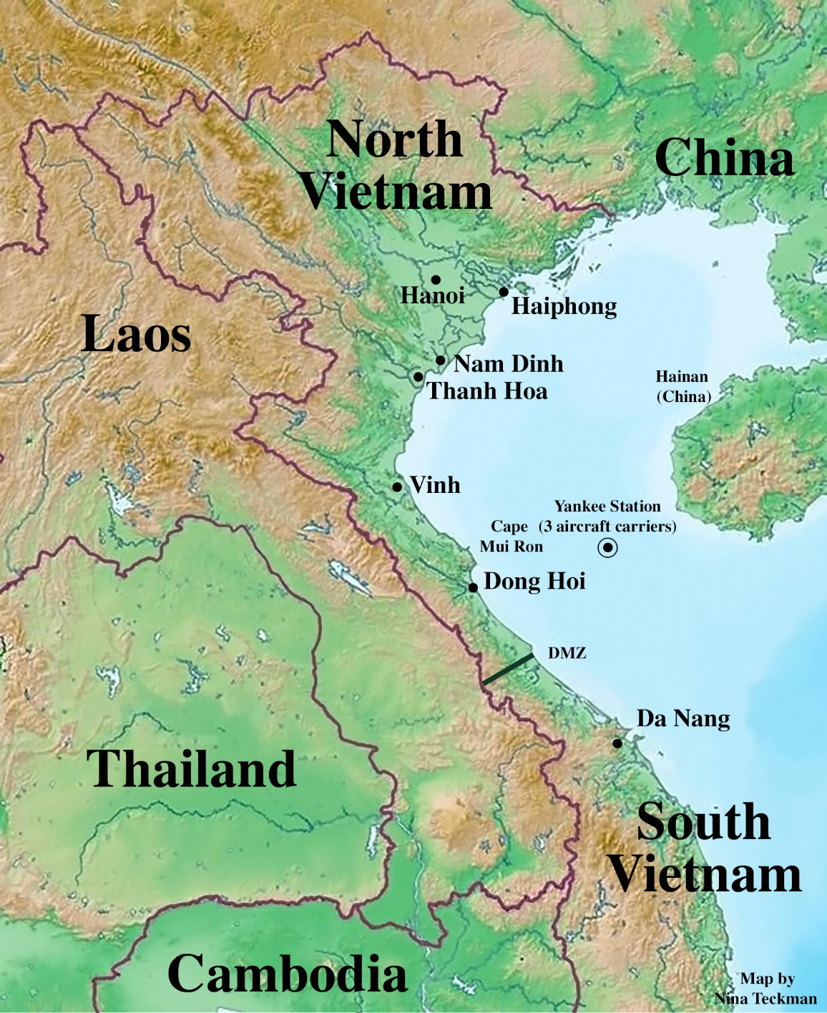
This map shows the topography of North Vietnam. The low-lying areas that are suitable for agriculture are shown in green. That’s also where the cities and villages are. And that’s where the anti-aircraft defenses (SAMs and flak) are. And that’s where our targets are. The rumpled green indicates broken terrain, frequently karst formations. The brown areas are mountainous, in many cases covered with tropical jungle. Few people live in the mountains. It is very difficult to put SAMs and flak in the mountains. So, it’s pretty safe for our pilots to fly over the mountains to reduce the the time of exposure to flak. Because the SAM’s have a range of fifteen miles, they can cover some of the mountainous areas, but not all.
If a pilot is in damaged plane that cannot make it to the Tonkin Gulf before ejecting, they try to make it to the mountains or karst formations where they might be able to eject, avoid capture and be rescued.
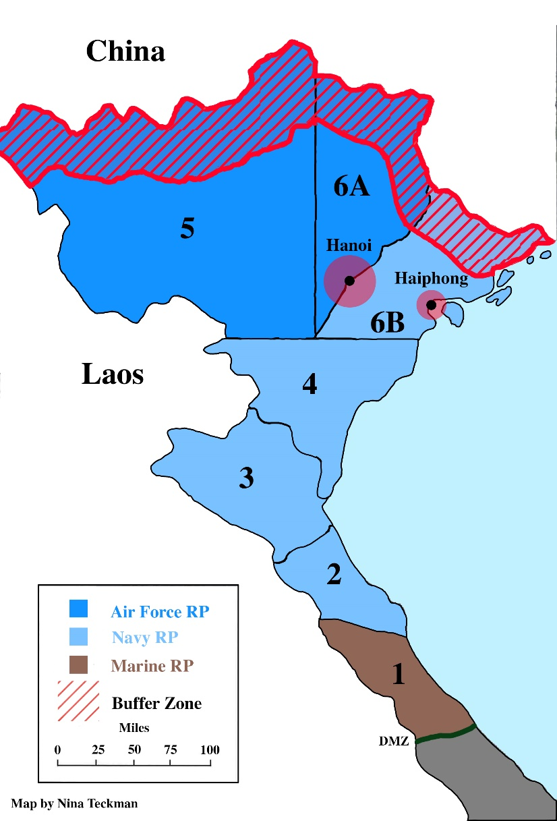
Earlier in the war both the Navy and the Air Force were flying over North Vietnam (NVN). There was a lot of mutual interference and difficulties coordinating the air operations of both services. For example, for about four months on the previous cruise a number of Oriskany’s A-1 Spads were being kept by the Air Force in Thailand, because the Air Force had nothing like the SPAD that could protect their rescue helicopter trying to extract a downed AF pilot in North Vietnam. So, Commander-in-Chief Pacific in Hawaii divided NVN into Route Packages. Route Package (RP) 1 is the responsibility of the Marine Air Base at Danang, which is in the northern part of South Vietnam. RPs 2, 3, 4 and 6B are the responsibility of the Navy carriers on Yankee Station. RPs 5 and 6A are the responsibility of Air Force flying from bases in Thailand. There is a 30-mile radius restricted (no bombing) area around Hanoi, the North Vietnamese Capital. There is a ten-mile radius restricted area (no bombing) around Haiphong, North Vietnam’s principal seaport. The red striped area is a no-fly zone along the Chinese border.

All the bombing is managed under a Pentagon program called Rolling Thunder. The objective of Rolling Thunder is to attack the transportation network of North Vietnam to destroy or diminish the capability of the North Vietnamese to move weapons, ammunition, supplies and food to the Viet Cong guerillas in South Vietnam.
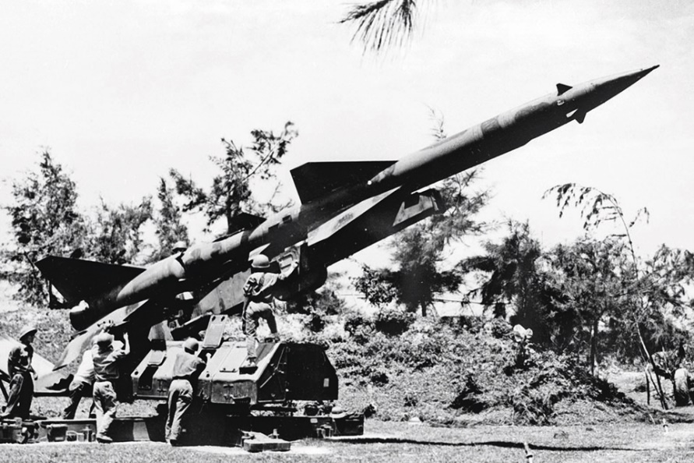
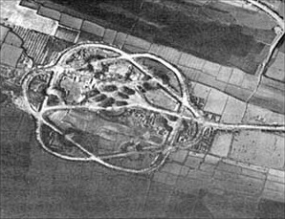
During Oriskany’s pre- vious cruise in ’65, the SA-2 surface-to-air missiles (SAMs) were arriving in North Vietnam from the Soviet Union. By now they had been well established in the northern half of the country. The SA-2 deploys in a battery of six missiles, each on its launcher/wheeled trailer, and a control van with the control radar (codenamed Fan Song) on top. The preparation of a launch site presents a distinctive visual signature to our overhead photo reconnaissance. Because the missile and trailer have to be towed to its launch position, each missile position has a drive-through revetment. The control van is in the center of the six missile launcher revetments. By now, however, the NVN have constructed dozens of launch sites all over the northern part of the country (Hanoi-Haiphong and the Red River delta). Most of them are unoccupied on any particular day. Which walnut shell has the pea? The SAM defenses are augmented by a plethora of flak guns firing 37mm, 57mm and 85mm shells. The more millimeters the larger the explosion and distribution of metal fragments (shrapnel) to make holes in airplanes.
Unique overhead signature of an SA-2 SAM site.
A Soviet SA-2 surface to air missile (SAM)

In our briefing compartment in the strike ops/intel center we have a sliding order of battle (OOB) briefing board. It’s a map of NVN with a red-headed stick pin at each SAM site we think is occupied, and yellow-headed stick pins for the flak sites. The red SAM pins have an acetate 15 mile range circle around each site that indicates the coverage of the SAM threat to our planes. As the SAM units move around, we move the acetate circles. At this point in the war there are overlapping SAM circles in the north (RP6A), single SAM site coverage in central area of the coast (RP4), and no SAMs in the southern coastal area (RP2) of NVN.
Our pilots have discovered that they can outfly the SAMs, meaning that if they make a radical maneuver the Fan Song radar cannot maneuver the SA-2 missile fast enough to keep up with the changing location of its target. The SA-2s are big missiles designed by the Soviets to shoot down big, high-flying American B-52 bombers (the Aluminum Overcast). It’s easy to see them when they launch and rise up with a bright exhaust flame and a prominent trail of white smoke. If the pilot sees it as moving up, down or sideways, it’s not tracking him. But if it’s not moving and just getting bigger it’s tracking YOU! It’s time RIGHT NOW for a Split S, or some other whifferdill! But if you don’t see it . . . game over! One way to foil the SA-2 is to fly so low that the Fan Song can’t get a good track on you. Remember the Sandblower profile in my ride with John Davis? That was tried earlier in the war, but that made everyone in North Vietnam with an AK-47 assault weapon an anti-aircraft gunner, and the loss rate was prohibitive. It is now tactical doctrine to stay higher, outfly the SAMs, and maintain altitude for accurate bomb deliveries on the target.
All our fighters and bombers also have a small gee-whiz deceptive electronic warfare (EW) ALQ-51 transmitter tuned to the Fan Song frequency. When the NVN radar operator selects a target for his SAM, he switches his Fan Song to the target acquisition mode. This increases the frequency of the radar pulses. The ALQ-51 detects and recognizes this pulse frequency increase and starts retransmitting its own pulses, but at the same frequency and with a microsecond time delay, and stronger than the radar echo the Fan Song is expecting. The Fan Song locks on to the stronger false radar echoes, and “thinks” that the target aircraft is some distance behind the actual aircraft. It guides the missile to empty sky a safe (for the airplane) distance behind its target. In addition the ALQ-51 turns on a red warning light in the cockpit when it detects a Fan Song. When the Fan Song increases the pulse frequency, which it must do to guide the missile, the ALQ-51 gives an audible warble warning in the pilot’s helmet headphones. Then everybody’s head is up and scanning for a missile launch/flight.
The Navy has recently developed a new anti-radiation missile that homes on radar antenna emissions. When it gets to the radar antenna it explodes. The warhead is not very big, but it’s got a lot of shrapnel that perforates and ruins the antenna and perforates the control van beneath the antenna, sometimes killing or wounding the operators inside the van. It’s called the Shrike. Our former Skipper, Jack Shaw, had been the Shrike test pilot at the Navy experimental Squadron VX-5 in the Mojave Desert that developed the flight tactics for the Shrike. His experience determined that the VA-164 Ghostriders would be the Shrike squadron for Air Wing 16 on the Oriskany. The original A-4E’s cockpit had a radar display in the center of the pilot’s instrument control console. It was intended for the A-4 to have some capability to navigate at night or in bad weather. The VA-164 A-4E’s have had the navigation display removed and new display that enables the pilot to see the direction of the electronic emissions detected by the sensor on the Shrike. The Navy name for the program is Iron Hand. Our Ghostrider pilots get additional training in using the system. If the air wing is not flying in SAM protected areas, the Ghostrider A-4’s that would be used for Iron Hand are used as bomb-droppers.
NVN flak guns can be aimed manually by the gunner or by input from a Fire Can radar. To minimize their effectiveness, our aircraft fly in loose formation that allows each plane to bob and weave like a boxer but remains within its formation position as it makes its way to the target. We learned and practiced it at Fallon. The bobbing and weaving takes advantage of the time it takes for the flak shells to get to the distance and altitude of the target. The airplane is no longer at the place in the air where the anti-aircraft shell was aimed by the Fire Can or the gunner.
As we get ready for our first combat operations over North Vietnam, our enemy OOB briefing board is showing a dense network of overlapping SAM range circles over the Hanoi and Haiphong areas in RP 6A, In RP 4 there is intermittent SAM coverage, suggesting that they are having some logistic difficulty sustaining them farther to the south, and/or they are moving them around frequently to avoid Shrike strikes. In RP’s 3 and 2 there are no indications of SAMs. Because the A-1 Spads do not have the speed and maneuverability to outfly the SAMs, it is CTF 77 policy that their armed reconnaissance by Spads is restricted to RPs 3 and 2.

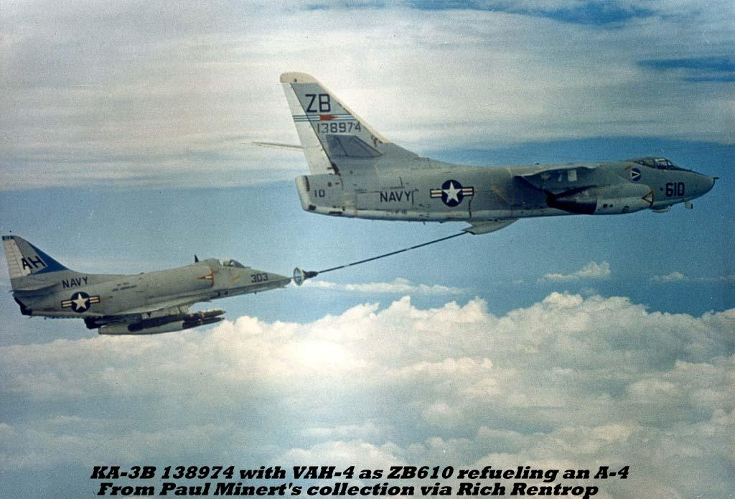
In addition, our A-3 Skywarrior strategic bombers are no longer allowed to fly over North Vietnam. They are just too big and unmaneuver- able to avoid both the SAMs and the radar-directed flak. Now their mission becomes aerial tanking. They position themselves in the vicinity of our ship during launches and recoveries and move just offshore when our planes are over NVN. The big gas station in the sky is known affect- tionately as the “Whale.”
Here is a Saints’ A-4 topping off his gas tanks from one of Oriskany’s Whales before heading out for a strike mission.

On 8 July we arrive on Yankee Station and begin cyclic operations with the A-4’s and the A-1’s flying armed reconnaissance (recce) missions in the southern half of North Vietnam. The objective is to destroy the transportation vehicles and infrastructure by which NVN is moving the means of war south to the Viet Cong. So, the desired targets are bridges and roadways, trucks, trains, and barges (also called water-borne logistic craft, or “wiblics”). In addition, before our arrival, the Pentagon expanded the target list to include petroleum, oil and lubricants (POL). The idea is to stop the trucks by destroying all the gasoline, oil and lubrication in North Vietnam. NVN neither produces nor refines any petroleum products. So that means oil tanks, pipelines. oil cars on the railroads and tanker trucks are now targets, and a high priority. If the pilots can’t find anything mobile and they’re running out of time, they’ll bomb a temporary bypass bridge, or put a few more craters in the road that runs along the coast, then head back to the ship.

The basic element of combat operations is the section of two planes; the more experienced section leader and his less experienced wingman. The two planes have about an hour over NVN to find and bomb a target. After they return, they write up the gripe sheet for the maintenance folks, then the section leader reports to our debriefing compartment. Sometimes the wingman tags along.
Sometimes they find a wiblic or two or some trucks; more often they bomb a flimsy bypass bridge or put another crater on Route 1. And sometimes they just plain miss. When they miss, we write that they “cratered the approaches to the POL highway.” That means that, if you were walking across a rice paddy toward the highway, you would have to walk through or around the fresh crater in the rice paddy to get to the highway. We call it the POL highway because it is possible that the highway is being used by fuel trucks. That way we’re showing that the Oriskany is giving full support to the Pentagon latest guidance (while continuing to hit the same targets as before).
Our bombing is pretty effective in terms of hitting the targets. All the bridges along Route 1, except for the (in)famous one at Thanh Hoa, have already been downed, but, every night, repair gangs put up a temporary bridge or pontoon bridge. The trucks, hiding during the day in truck parks under the trees, come out at night like cockroaches and cross the temporary bridges. The next day we find the temporary bridge and knock it down again. Pontoons and materials to repair the bridge are well-hidden and dispersed along the river edges. Local repair gangs work overnight to fill in any craters on the pavement of the highway. Repairing a crater in a rice paddy is up to the local farmer. Sometimes we find and bomb truck parks and destroy trucks by the dozens. Nevertheless, by prodigious effort and organization, the North Vietnamese are able to intermittently keep their lines of communication to the Viet Cong in South Vietnam open. We slow everything down, and exact costs in equipment and people, but we don’t stop it.
Sometimes we fly Alpha strikes against fuel storage facilities. An Alpha strike is an all-out attack by the entire air wing against one target (described previously on pp xx). Leading Alpha strikes is the epitome of combat and requires the most experienced and aggressive aviators.
Each Oriskany Alpha strike is led by CAG Spruit or one of the Ghostrider or Saint skippers or XOs. If the Alpha strike isn’t in the highly-defended Hanoi-Haiphong-Red River delta area, the lead is sometime given to a Ghostrider or Saint LCdr. Leading an Alpha strike is also an opportunity to win a high-grade combat medal (Bronze Star, Distinguished Flying Cross, Silver Star or even a Navy Cross, the Navy’s highest medal for heroism). Combat medals are important for the aviators who have decided to stay in the Navy. Medals advance their careers. Many would-be admirals never make it that far because they never happened to serve in a leadership position during a war or were in the Atlantic Fleet when the war was in the Pacific. In the competition for promotion, the bemedaled tend to win out over the unmedaled.

On 8 July, our first day on the line, the XO of the VF-111 Sundowners, Cdr Al Williams, turns in his wings because he feels he can’t provide “leadership in combat.” He refers to an ejection incident earlier in his career that keeps his focus on the instruments. Leading in combat requires focus on what’s going on outside the plane. He’s on the next Carrier On-board Delivery (COD) aircraft to Cubi, but his passenger seat comes loose during the catapult shot. He is severely injured. The COD immediately returns and lands on the Oriskany where he undergoes hours of surgery that save his life. Several days later he is put on a COD to Cubi and the Naval Hospital there. His replacement is Cdr Bob (Raz) Rasmussen who will be a great leader of his men through the ordeal of the ’66 and ’67 cruises.

On July 11, our fourth day on the line, we fly an Alpha strike against POL tanks near Dong Nam in “Indian Country” 20 miles northeast of Hanoi. Rather than fly directly through the densest defenses covering the Red River Delta, the strike group does a big Northeast end-around, and goes feet wet around Cam Pha while carefully avoiding the 20 mile no-fly zone along the Chinese border. They then follow a jungled mountain ridge to their target. LCdr “Butch” Verich and Lt Rick “Bulb” Adams of the VF-162 Hunters in their F-8 Crusaders are flying TarCAP between the

Zoom in map to show bulb adams down

target and the enemy MiG bases to the west. The NVN fire SAMs that force the strike group to a lower altitude. Nevertheless, the A-4s are able to roll in from the lower altitude and drop their bombs on target. They set afire two large POL tanks and damage another. On egress, however, Rick Adams’s Crusader is hit by flak, and, with the rear of his plane afire, he is able to get it over the same ingress ridgeline north and east of the of the target before ejecting. It is a rough and jungled area with good prospects for a helicopter pickup. Butch Verich sees where Rick has landed and orbits above to deter any attempt to capture Rick and to provide directions to our four ResCAP A-1 Spads orbiting off the coast. Gordon Smith, the skipper of the VA-152 Aces, and his wingman keep their Spads low and fly to Rick’s location. Smith assesses that the situation is favorable for a rescue and calls in the rescue helicopter from the Northern Search and Rescue (SAR) destroyer which is hovering off the coast, escorted by two Spads (Eric Schade and Jack Feldhaus). The helo arrives over Rick Adams and extracts him from his predicament, while our four A-1s blanket the area with ordnance to discourage any locals from interfering. Butch Verich is flying top cover to keep away any MiGs. The helo delivers Rick to the Oriskany four hours later. The key to the successful ResCAP was the superior judgement by skipper Gordon Smith who recognized that there was a fleeting opportunity for a rescue deep in “Indian Country” and had his Spad squadron superbly trained for it.
“Bulb” Adams had been shot down over North Vietnam and rescued during the previous cruise. He is the first aviator to be shot down twice over enemy territory and rescued each time. A Pentagon decision is made that Rick and any future aviators who have the same experience twice earn a “Get Out of War Free Card,” and are excluded from further combat flying.

I imagine a Pentagon conversation:
Captain “Silent Sam” Simpson, a submariner.
“I don’t think that’s such a good idea, Flash. Some guy might deliberately get shot down twice to get out of combat.”
Captain Dave “Flash” Pendleton, a naval aviator:
“Sam, how about I take you up for a spin in an F-4 Phantom, and I eject you at Mach 2?”
. . . A long pause.
Sam: “I see your point. I guess I can go along with it. Can you make nine holes of golf at Fort McNair tomorrow at 2?

We continue to fly Alpha strikes against POL and storage areas, sometimes with spectacular results: explosions and raging infernos. The pilots love secondary explosions! Secondary explosions confirm that they have destroyed something that’s gonna help our ground pounders in South Viet Nam. Bombing a warehouse that doesn’t explode leaves questions about whether whatever is inside is something of value. Maybe we destroyed a thousand brand new AK-47’s. Maybe. Maybe our bombs just redistributed the village’s rice ration. Maybe the Farmers’ Wives Cooperative will be up late for a week picking shrapnel out of sacks of rice.

Described above, pp XXX
Ten years later the Air Force will develop the A-10 Warthog specifically for ground support. The Warthog will distinguish itself in the Near East desert wars (Kuwait, Iraq, Afghanistan).
“They also serve who stand and wait.”
For the Spads, which have four 20mm machine guns each, and plenty of ammo, it’s an opportunity for some strafing runs. Our Skyhawks have only one 20 mm machine gun, and its 40 rounds are reserved for self-defense if enemy MiGs might attempt to shoot them down.
See above, page XX
The Congressional Medal of Honor (CMH) is given for heroism way beyond the call of duty. The CMH is an equal opportunity medal. Some involve leadership, but most are given to enlisted personnel who perform mighty deeds in intense combat situations. Forrest Gump’s rescue of his platoon commander in the movie of the same name is a fictional but representative example. About half of the CMH’s are given to the next of kin.
Basically, everything north of the Thanh Hoa Bridge, meaning the Hanoi and Haiphong areas and the Red River delta, comes to be called, among the pilots, “Indian Country.” It’s a reference to innumerable Western movies and TV series where pioneers enroute to California cross beyond the accustomed forces of law and order, and circle the wagons in a defensive formation if they see any Indians on horseback.
Target Combat Air Patrol (TarCAP). The fighters that are positioned to protect our bomb-droppers from enemy MiGs as our Skyhawks roll in and bomb their targets, and fly back to the ship
This is a summary of Peter Fey’s narration in Bloody Sixteen, pp 123-4.
Rick Adams is prematurely balding, and he shaves his head. That, and the shape of his head, result in the sobriquet “Bulb,” as in light bulb. Don’t ask me why Cdr Richard Bellinger, skipper of the VF-162 Hunters, is called “Limpy Dick.”

