



EMIRATES SANDS TECHNOLOGY

COMPANY PROFILE
Technology Solutions That Empower Your Business

CONTACT US

Tel : +971 4 386 99 70
Fax: +971 4 386 99 65
Website: emiratessands.com

ABOUT US

Established in 1994, Emirates SandsTechnology is aleading provider of IT hardware solutions and managed services.
We specialize in consulting, sales, and technical support for a diverse portfolio of medium to large enterprises.
Our culture is founded on trust, respect, and integrity, and we are committed to excellence inevery aspectof ourwork to build long-term customer loyalty.
By aligning with leading technology innovators, leveraging deep product expertise, and maintaining industry certifications, we distinguish ourselves in a competitive landscape.
We foster a performance-driven environment that recognizes individual contributions and teamwork, reflecting our dedication to training, developing, and rewarding our employees.

Our Core Strenghts:
Trusted partners with leading brands, delivering comprehensive IT solutions, managed services, and expert consulting. Certified expertise, customer-focused service, and a culture of innovation ensure reliable, high-quality results.

Our Vission
To be the trusted IT partner of choice, delivering reliable hardware solutions and managed services that empower businesses to thrive in a fast-evolving digital world.

Our Mission
To provide expert consulting, quality IT products, and responsive technical support through a commitment to integrity, innovation alignment, and customer satisfaction.

Our Team






Moawia ALLOUCH
Managing Director
Maan ALLOUCH
Managing Director
Majd ALLOUCH
Managing Director
Mazen ALLOUCH
Managing Director



Shilpa Dave
HR Manager
Kailash Sonar
General Accountant
Ahed Fahad
IT Specialist
Mansoor
Admin/Logistics



Jennlyn UNTALAN
Sales Head
Meqath Mani
Sales Officer
Sweety Manjani
Sales Officer
Khader Pasha
Sales Officer



Akari LWin
Sales Officer
Dairhene Thea
Sales Officer

Our Brands

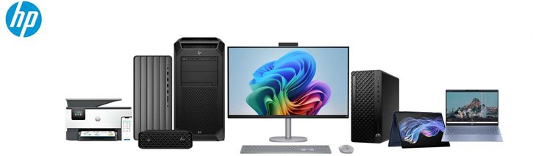
HP offers a comprehensive range of laptops, desktops, and printers for both home and business use, delivering reliable, high-performance devices designed to keep you productive and seamlessly connected.

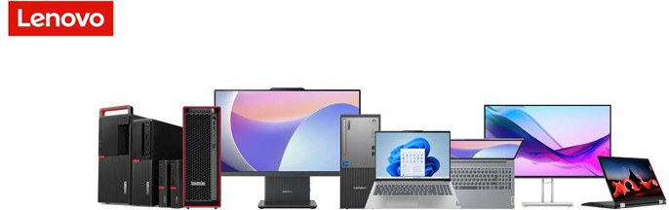

Lenovo offers a diverse portfolio of laptops, desktops, and smart devices for home and business environments, delivering dependable performance, innovative technology, and powerful solutions designed to enhance productivity and keep you connected.

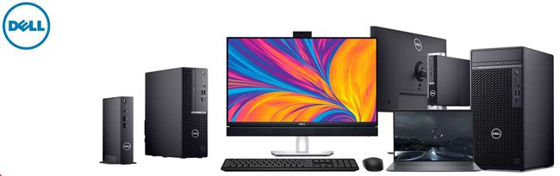

Dell delivers a broad range of laptops, desktops, and printing solutions for home and enterprise users, combining robust performance, advanced innovation, and dependable technology to empower productivity and seamless connectivity.

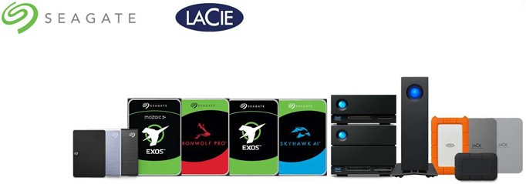
Seagate provides reliable and high-capacity data storage solutions, including internal and external hard drives and SSDs, designed to deliver performance, security, and scalability for both personal and enterprise needs.

LaCie offers premium external storage solutions engineered for creative professionals, combining sleek design, high-speed performance, and dependable data protection to support demanding workflows.

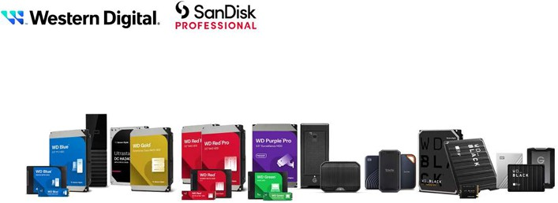
SanDisk delivers high-performance flash storage solutions including SSDs, memory cards, and USB drives, while Western Digital provides reliable and scalable HDD and SSD storage systems designed to meet personal, business, and enterprise data needs.

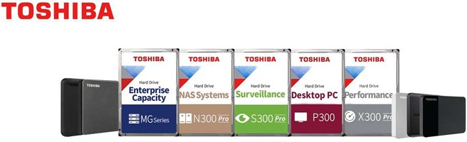
Toshiba offers durable and high-performance storage solutions, including HDDs, SSDs, and memory devices, designed for both personal and professional use.

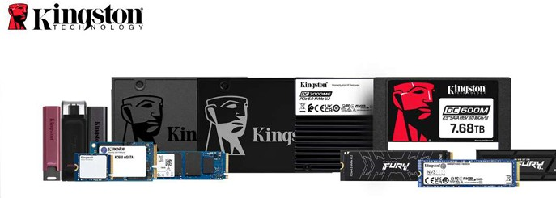
Kingston provides reliable and high-performance memory and storage products, including RAM, SSDs, and USB drives, designed to enhance computing performance for both personal and professional users.

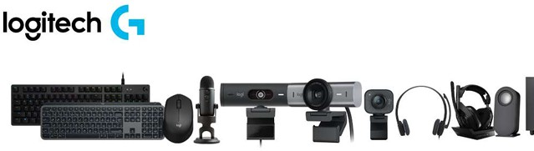

Logitech offers innovative and reliable peripherals, including keyboards, mice, webcams, and audio devices, designed to enhance productivity, creativity, and connectivity for both home and professional users.

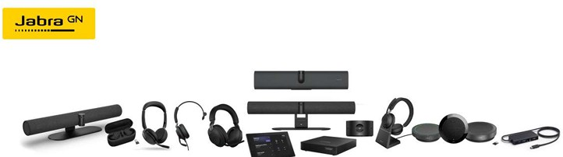

Jabra delivers high-quality audio and communication solutions, including headsets, earbuds, and speakerphones, designed to provide clear sound, comfort, and seamless connectivity for professional and personal use.

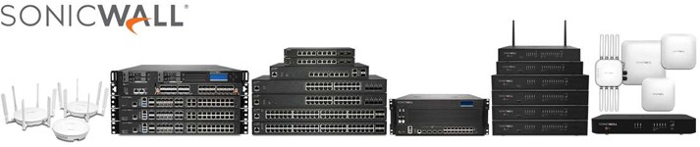

SonicWall provides advanced network security solutions, including firewalls, VPNs, and threat protection, designed to safeguard businesses with reliable, high-performance cybersecurity and secure connectivity.

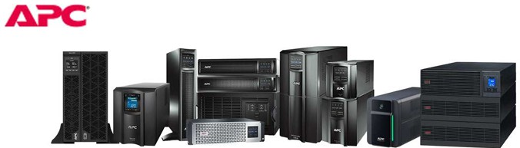

APC delivers reliable power protection and management solutions, including UPS systems, surge protectors, and power distribution units, designed to ensure uninterrupted operations and safeguard critical equipment for home and business environments.

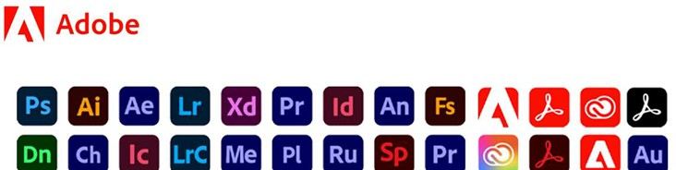

Adobe offers a comprehensive suite of creative and digital solutions, including Photoshop, Illustrator, and Acrobat, designed to empower professionals and individuals with powerful tools for design, content creation, and document management.

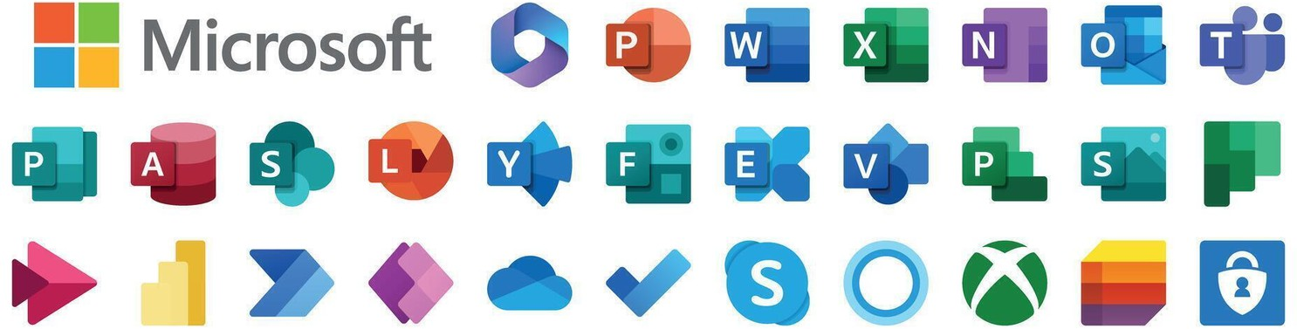

Microsoft provides a wide range of software, hardware, and cloud solutions, including Windows, Office 365, and Azure, designed to enhance productivity, collaboration, and innovation for both individuals and businesses.

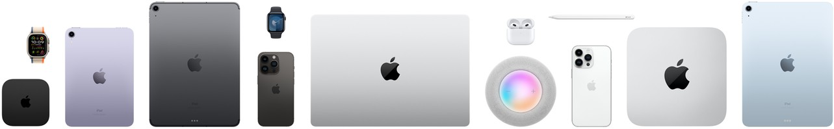

Apple designs and delivers premium devices and services, including iPhones, MacBooks, iPads, and software ecosystems, offering seamless performance, innovation, and user-friendly experiences for both personal and professional use.

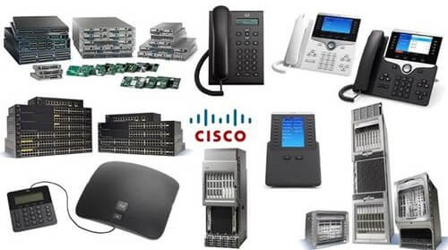

Cisco provides advanced networking, cybersecurity, and collaboration solutions, including routers, switches, and Webex, designed to enable secure, reliable, and scalable connectivity for businesses of all sizes.

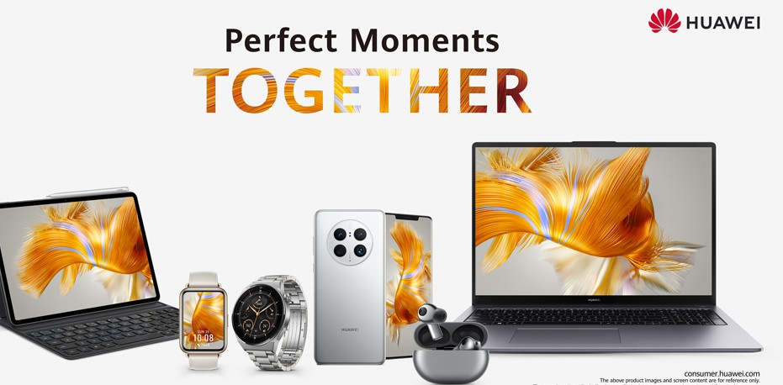

Huawei offers a wide range of innovative devices and solutions, including smartphones, networking equipment, and cloud services, designed to deliver high performance, connectivity, and seamless digital experiences for both consumers and enterprises.

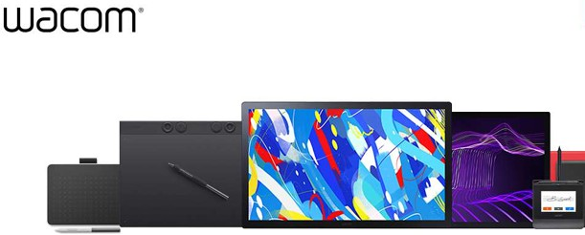
Wacom provides professional creative tools, including pen tablets, displays, and styluses, designed to deliver precision, responsiveness, and a natural drawing experience for artists, designers, and creative professionals.
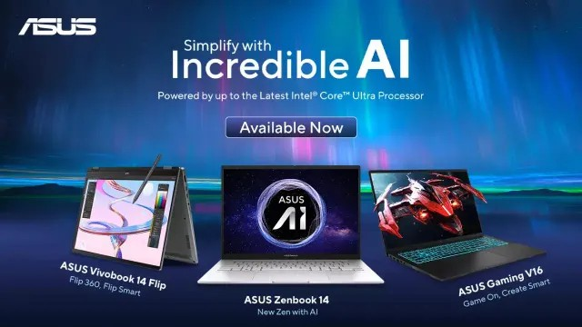

ASUS offers a wide range of laptops, desktops, motherboards, and peripherals, delivering high-performance, innovative, and reliable solutions for both personal and professional computing needs.


Our Core Strength

Emirates Sands Technology delivers end-to-end IT infrastructure solutions, designed to empower businesses and drive growth. Our comprehensive offerings include:

- Storage Solutions – Scalable and secure storage systems to meet the evolving demands of your enterprise.
- IT Devices & Gadgets – High-performance desktops, laptops, printers, and peripherals for seamless operations.
- Managed Services & Technical Support – Proactive maintenance, dedicated support, and tailored IT services for optimal efficiency.
- Cloud Services – Flexible cloud computing, storage, and collaboration platforms to enhance productivity.
- Database Management – Robust database solutions for secure, reliable, and efficient data handling.
- Custom Technology Solutions – Tailored IT strategies and implementations to support unique business objectives.
- Cybersecurity & Network Solutions – Advanced tools to protect your digital assets and maintain uninterrupted operations.
- Consulting & Strategic Planning – Expert guidance to optimize IT investments and align technology with business goals.

With a commitment to innovation, reliability, and customer satisfaction, Emirates Sands Technology ensures your IT ecosystem is optimized for growth, agility, and long-term success.





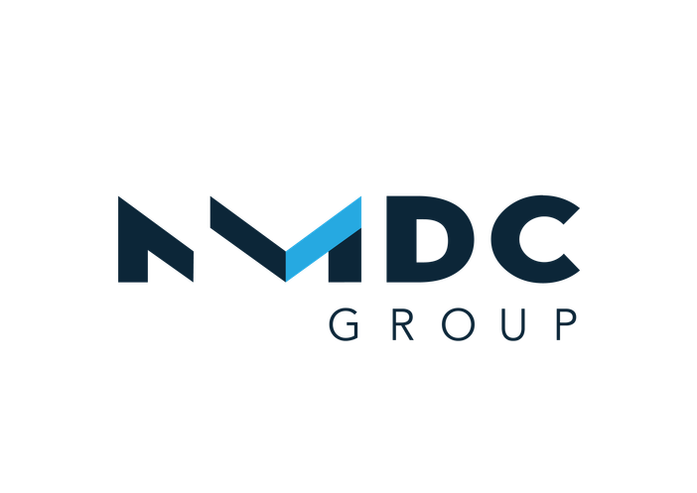








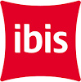


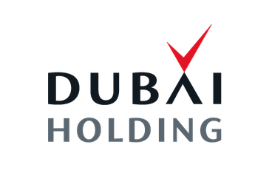





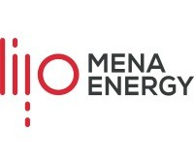








Our Clients

At Emirates Sands Technology, we believe technology is the backbone of every successful
business. By combining innovation, expertise, and reliable solutions, we empower our clients to achieve operational excellence, scalability, and sustainable growth.

Our commitment goes beyond delivering IT solutions - we build lasting partnerships based on trust, integrity, and mutual success. Together, we transform challenges into opportunities and ensure your business stays connected, productive, and future-ready.

